The Invasion of Ukraine, and the Demise of Russia
From: https://medium.com/@jessesandoval/the-invasion-of-ukraine-and-the-demise-of-russia-44dd6954fff3
Author: Jesse Sandoval
Date: Feb 12, 2022, 12 min read

The Invasion of Ukraine, and the Demise of Russia
A Russian invasion of Ukraine is simply the latest re-iteration of an unresolved tension between Russia and its western neighbors. Until the tension is permanently resolved, it will remain a simmering threat to both sides.
“In geopolitics, major conflicts repeat themselves.” — George Friedman
“I have no way to defend my borders but to extend them.” — Catherine the Great
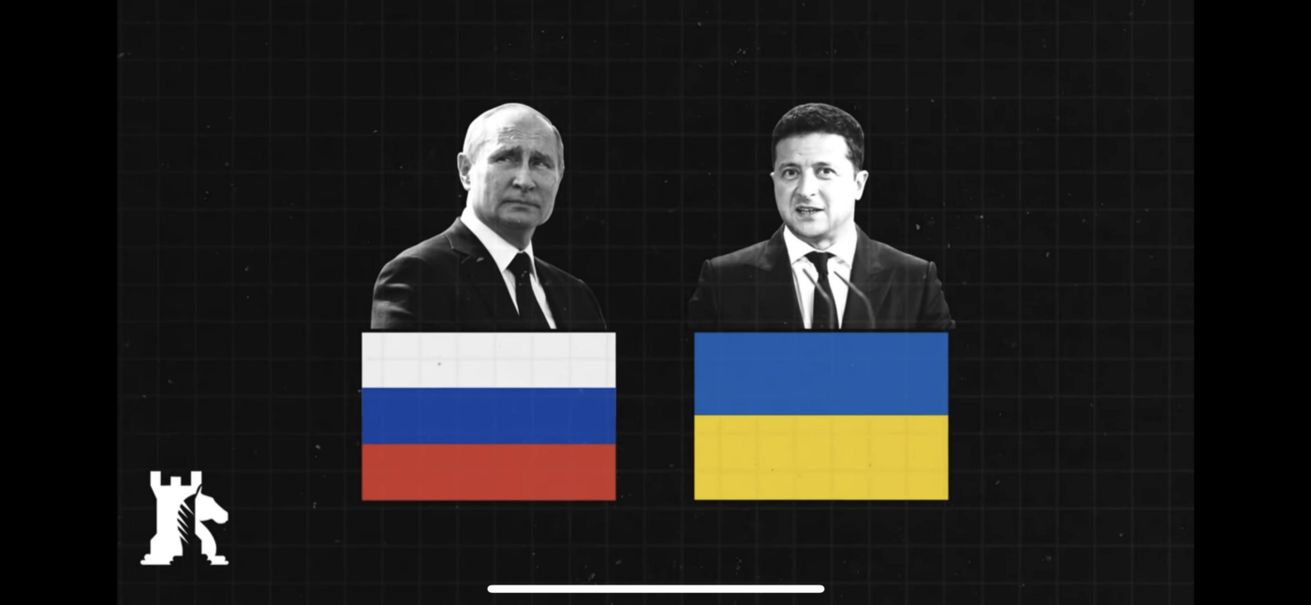
President Vladimir Putin of Russia and President Volodymyr Zelensky of Ukraine. Courtesy of Caspian Report

The Background
The end of the Cold War was a missed opportunity. Had Russia collapsed into several weak, fragmented states, the Americans, Europeans, Japanese and Chinese could have moved in for the kill. The outcome would have been the permanent end of the Russian state as an offensive threat to its neighbors. On the other hand, had the Americans and NATO navigated a delicate path towards integration of Russia and the Commonwealth of Independent States (CIS) into an enlarged version of NATO, weighed down for future decades by the process of integrating former Soviet armies into a joint command structure, Russia’s threat to its western neighbors and vice-versa could have been blunted, but not fully eliminated.
Instead [of either of these outcomes], Russia managed, against all odds, to re-emerge as an integrated, federal state with the ability to project military power abroad. As a result, thirty years after the end of the Cold War, Russia remains shackled to the existential struggle between it and its western neighbors.
Based on this assessment, it appears there are only two permanent states of affairs for Russia’s existence. One in which it is constantly seeking to expand its borders or zones of influence in a way that protects its territorial integrity and its form of centralized government. The other, where it is divided and conquered by its neighbors. Russia has experienced both scenarios over the last thousand years. Today’s conflict with Ukraine is simply the latest iteration of this inexorable struggle.
At the heart of the current conflict is the question of Russia’s territorial integrity.
Russia is the world's largest country.
Russia has the world’s largest coastline.
To the south, Russia’s borders are clearly defined by the Black Sea, which borders the impassable Caucuses mountains, and then leading to the Caspian Sea, essentially protecting it from Turkey and Iran.
Further east, the vast Kara Kum Desert makes way to the Himalaya Mountains, providing it protection against China along the south east. Invading Russia from the far east is a practical impassibility given the vast wilderness of Siberia, essentially protecting it from China and Japan.
The only pathway to an invading force is on Russia’s western border with Europe; the same pathway taken time and time again by Germans, French, Swedes, and Poles. The lack of sufficient landmarks to protect Russia on the west from potential threats means it shall always seek to push its westward border further either through direct control or through buffer zones (zones of influence).
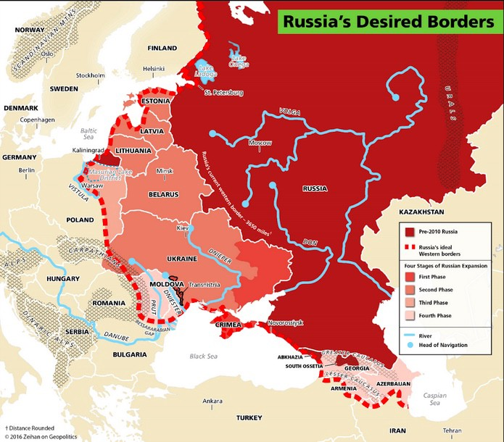
Russia’s desired borders and zones of influence. Courtesy of Zeihen on Geopolitics.
Russia is thus always vulnerable to attack or destabilization from its western border. Russia’s vast land and poor transportation infrastructure make it difficult to defend itself against simultaneous threats along its entire periphery. Lastly, and most importantly, Russia’s demographics are collapsing, making it impossible for it to field an offensive army larger than the est. 130,000 troops stationed along Ukraine’s border today.
Thus Russia’s grand strategy remains the same: to have defense in depth through geographic expansion of its borders and buffer zones. Russia needs to accomplish these objectives while its demographics enable it to field sufficient offensive military strength. All of Russia’s actions stemming from this defensive posture (e.g. the annexation of Crimea, South Ossetia, Abkhazia), will appear to its neighbors as offensive, thus resulting in an eventual confrontation.

The Situation
Ukraine and Belarus mean everything to Russians. Without either country as a buffer between them and the powers further west, Russia would be in mortal danger. Ukraine, therefore, cannot join NATO without dealing a mortal blow to Russia in its current state. Moscow is 400km from the Belorussian border, and Volgograd 300km from the Ukrainian border. Russia would immediately feel pressure against its tenuous hold on the quasi-independent states of Chechnya and Dagestan, threatening its access to the Black Sea, and to oil and gas supplies in the Caucuses.
In short, if Ukraine joined NATO, Russia would have to invest significantly more in defending its borders against a perceived NATO threat. However, Russia has neither the demographics nor the economic strength to underpin such a defensive strategy beyond the year 2030. On the other hand, a regime change in Kyiv resulting in the re-introduction of a pro-Moscow government would be an ideal outcome for Russia. Unfortunately for Russia, constant subversion and limited military conflict in Ukraine’s east have failed to produced this outcome. Therefore, from Putin’s point of view, an escalation of military threats is Russia’s last viable remaining option. The longer Russia waits in committing to a military option in Ukraine, the more expensive and more risky such an option becomes. Therefore, if Russia is to act to deter Ukraine from joining NATO for the next twenty years, it needs to act now.

The Russian Perspective
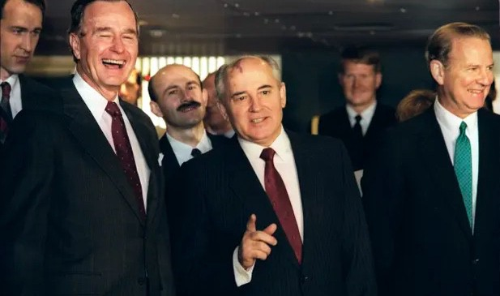
President George Bush (left) with the Soviet leader, Mikhail Gorbachev, and US secretary of state James Baker (right) in 1989. Photograph: Jonathan Utz/AFP/Getty Images
From the Russian perspective, the collapse of the Soviet Union has only led to greater threats against Russia’s territorial integrity and its centralized government. At the core of Russia’s grievances against the USA and NATO is the belief that the west broke a promise not to expand NATO eastward to Russia’s borders. Between 1989–1990, Secretary General Gorbachev agreed to the unification of West and Easter Germany, and the enlargement of NATO to include East Germany, on the condition that NATO would not expand further east, nor would NATO deploy a permanent presence in former Warsaw-Pact countries. This of course is a highly contested point. No treaty or memorandum of understanding was ever drafter [drafted] and signed by any of the parties. The assurances had been given verbally between then Secretary of State James Baker and his Soviet counterpart. In 2007 at the Munich Security Conference, President Vladimir Putin famously pointed to these grievances as the cause for a loss of trust, and escalation of tensions.
From the Russian perspective, NATO experienced a ‘big bang’ of eastward expansion since 1997, which has continued relentlessly, and may in short order include Ukraine. NATO’s expansion without more robust confidence-building measures to include Russia and CIS states into planning and consultations (e.g. through structures like the [PfP] Partnership for Peace, Planning and Review Process [PARP]), has forced it to invest more resources into defense-enhancing technologies and weaponry. NATO’s expansion has also raised tensions by empowering former Warsaw Pact states to raise territorial grievances with Russia, which they would otherwise not bring up with the backing of NATO.
Politically, NATO expansion has served as a precursor for European Union (EU) membership, resulting in political changes leading to governments that are generally hostile to Russia. Russia has seen the evolution of ‘colored’ revolutions across its periphery, resulting in governments overtly hostile to its influence.
- First was the Orange Revolution in Ukraine in 2004–2005, followed by
- the Rose Revolution in Georgia in 2007–2008, followed by
- the Maidan Protests in Ukraine in 2014, and most recently
- the Belarusian protests of 2020–2021, and
- the Kazakhstan protests of 2022.
From Moscow’s point-of-view, these protests are at best covertly supported, and at worst, overtly encouraged by the West. Adding more justification to this belief is the tacit support that protest leaders within Russia like Alexei Navalny have received from the West, leading to a credible claim of election meddling and subversion by the West in Russia’s internal state of affairs.
Russia is therefore left with the only option of actively enhancing is military readiness, and preparing any and all military options to ensure that its historic enemies do not control the buffer zones that it believes it needs to safeguard its territorial integrity. As further evidence, Russia can point to the attack on Serbia by NATO in 1999, Armenia’s recent war with a Turkish-backed Azerbaijan in 2020, a Georgia or Ukraine supported military by the US and NATO through direct arms shipments and training, or a Finland and Sweden integrated within NATO’s command structure.
If Russia is to deal a multi-decade set back to NATO, it must do so first in Ukraine, where it has the offensive military capacity to launch a three-pronged, multi-stage attack in a lightning campaign to achieve a regime change in Kyiv to a pro-Moscow government. Moscow’s ideal end game would be the collapse of President Volodymyr Zelensky’s government, the federalization of Ukraine in which Russia could permanently influence the eastern half of Ukraine, and the indefinite integration of Belarus into Russia’s defensive strategy through the presence of a permanent military presence. Winning in Ukraine, would then give Moscow greater leverage in pressuring USA and NATO to reduce their semi-permanent presence within the three Baltic states.
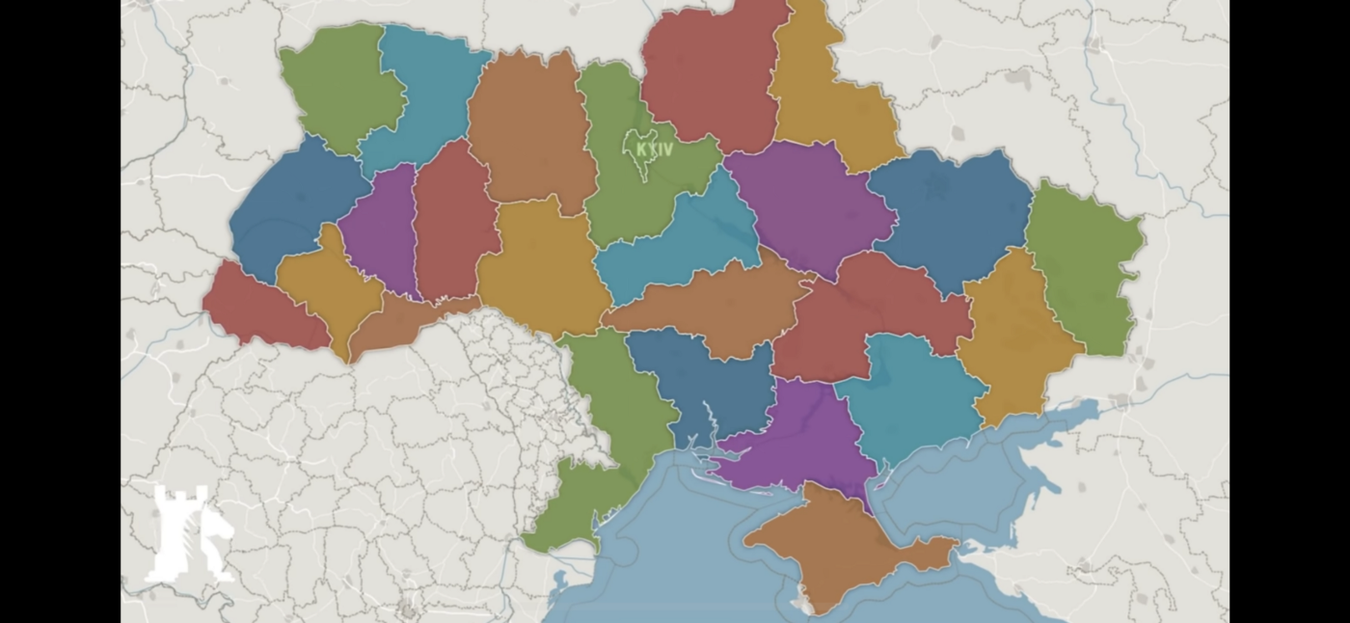
Ukraine under a federal, not unitary, political structure
The American & NATO Perspective
From the American and NATO perspective, the collapse of the Soviet Union led to a once-in-a-lifetime opportunity for greater peace and prosperity in Europe, and throughout the world.
The unification of Germany resulted in an immediate reduction in hostilities between the Soviet Union and NATO. The unification of Germany also provided the European Union with a new economic strategy; enhancing its economic competitiveness by accessing low cost labor from Eastern Europe for advanced manufacturing and services industries in Western Europe that could compete globally across every major sector.
The expansion of NATO eastward to include Poland, Czechia, and Hungary in 1999 provided security stability in Eastern Europe at a time when the former Yugoslavia had collapse into civil war, leading to fears of political instability throughout Southeast Europe.
The ‘big bang’ expansion of both the European Union and NATO in 2004 to include Estonia, Latvia, Lithuania, Slovakia, Romania, and Bulgaria was, from the West’s point-of-view, the natural evolution of the European project, that is a single common market that provided economic prosperity, political stability, and above all, free of intrastate conflict through membership in NATO, a military alliance who’s [whose] success is not replicated anywhere else on the planet with the exception of the Five Eyes Alliance among the USA, Canada, UK, Australia and New Zealand.
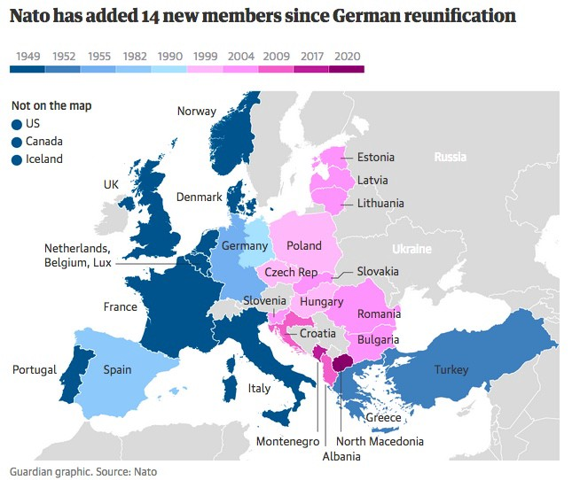
Seeing the success of its military alliance in reducing conflict within Europe, and providing the foundation for eventual European Union membership which has lead to greater economic prosperity, NATO and its strategic partners have continued their objective of expanding their influence eastward, into Russia’s historical domain, with the justification that these military and economic institutions are not hostile to Russia in nature, but in fact provide Russians with greater economic opportunities, and the possibility for future military cooperation with Russia. From NATO’s point of view, its eastward expansion provided greater security and stability for Europe, without coming at the cost of Russia’s territorial integrity.
However, with every step eastward, NATO was inevitably dialing up tensions with Russia. America’s push to establish anti-ballistic missile batteries in Romania, Czechia, and Poland with the pretext of countering an Iranian missile threats resulted in Russia placing similar offensive capabilities in Kaliningrad. Russia’s invasion of Georgia, and its loss of South Ossetia and Abkazia, was the moment when everything began to unravel for NATO-Russia relations. Russia’s participation in NATO’s PARP program came into question. The nail in the coffin came with the annexation of Crimea from Ukraine by Moscow following the Euromaidan protests of 2014, and the hybrid warfare resulting in the Donbas region of Ukraine. The fall out were economic sanctions against Russia, the closure of Russia’s bureau within NATO command, and the eventual placement of semi-permanent military presence of NATO troops in the Baltic states, Poland and Romania; resulting in increased hostilities between NATO and Russia air and naval assets throughout the Arctic, Baltic, and Black Seas.
Any invasion of Ukraine by Russia in 2022 would only result in a stronger military presence by NATO along Russia’s immediate frontiers, namely Kaliningrad, Estonia, Latvia, Lithuania and Poland. NATO would be plunged into a new, active Cold War.

The Wargame Scenario
Should Russia decide to invade Ukraine in the coming days, it will be Russia’s first, multi-front, multi-divisional offensive undertaking since World War II. The risk of failure is meaningful, given Ukraine’s formidable defensive capabilities. While a lightning campaign to surround Kyiv seems possible within four weeks, it's practically impossible for Russia to maintain a long-term security presence throughout Ukraine given that a third of Ukrainians are openly hostile and willing to take up arms against Russian troops. Russia, therefore, needs to achieve its political objectives as quickly as possible, and exit Ukraine before a counterinsurgency could result in a prolonged civil war throughout the country.
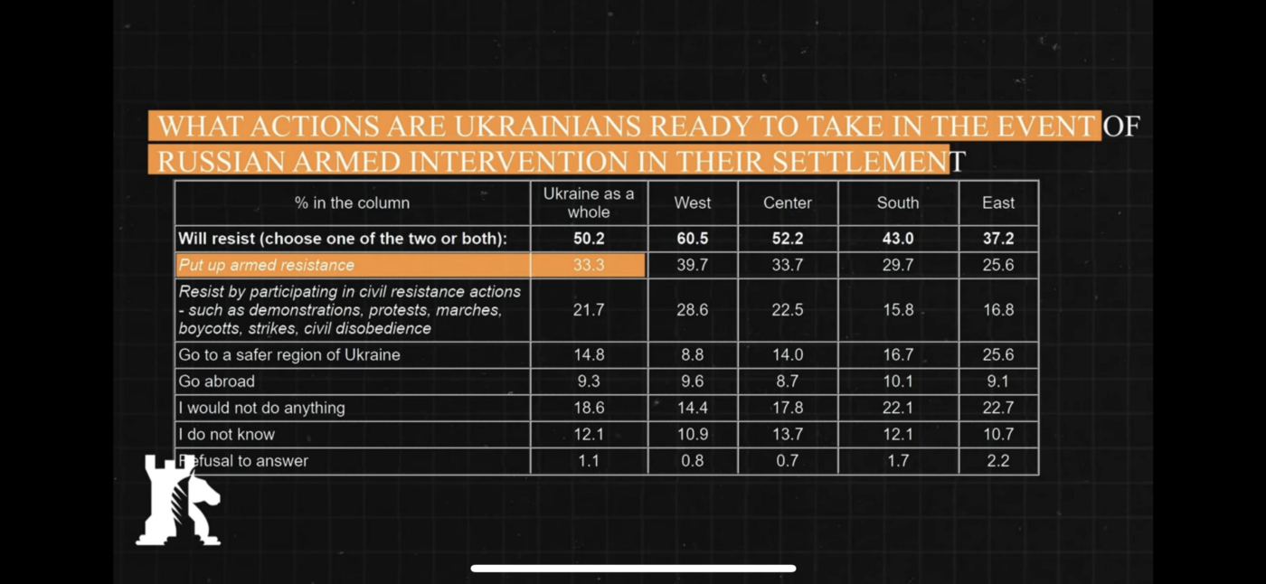
Ukrainian counter insurgency readiness. Courtesy of Caspian Report.
Russia’s operational plan seems to be divided into a southern strike at Odessa first, enabling it to cut off Ukraine’s sea access, and disrupt logistics along the Dnipier, preventing Ukrainian forces stationed in the western half from reinforcing the Eastern half. Second, Russia would strike towards Kharkov in a faint attack, while preparing its third and fatal blow against Kyiv through Belarus, via the Chernobyl area west of the Dnieper.
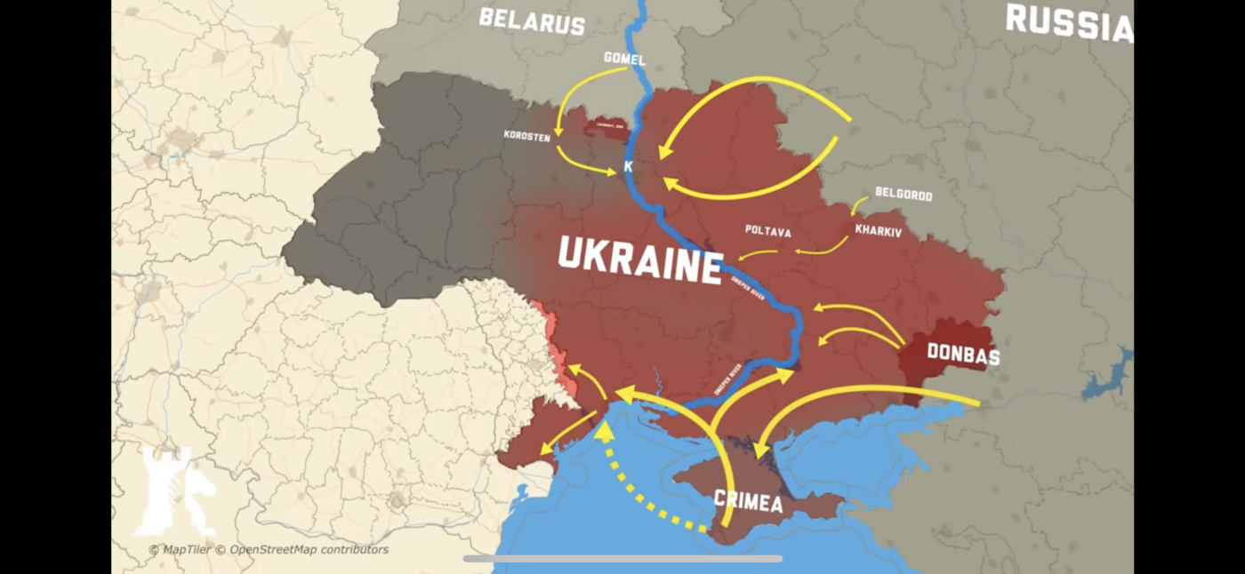
Russian invasion plans for Ukraine 2022. Courtesy of Caspian Report.
Amidst all this, Russia needs to consider the severe economic and security implications resulting from an invasion of Ukraine. Russia’s demographics cannot sustain its current military levels, therefore every Russian soldier lost in this conflict cannot be replaced in the coming years. This would be Russia’s last major military offensive.
Secondarily, the possibility of Russia being cut off from the SWIFT banking system of payment transfers means it would lose access to international creditors beyond China and perhaps some Gulf States. Russia’s economy would shrink further, making it more difficult to finance the necessary military expenditures required to keep up with a more robust NATO military presence throughout Eastern Europe. Lastly, Moscow has to consider the possibility that Ukraine may split in two, with an openly hostile Western Ukraine prepared to engage in offensive war against Russian controlled Eastern Ukraine indefinitely.

Is De-Escalation Possible?
In the short-term, yes. In the long-term, no.
From the Russian perspective, de-escalation could be achieved if the White House, in concert with NATO command, communicate to Ukraine and Russia an indefinite desire to prevent Ukraine’s ascension into NATO. The ‘Finlandization’ of Ukraine, essentially the continuation of the status quo, would give Putin the opportunity to back-down while achieving a geopolitical victory.
From the American and NATO perspective, de-escalation can be achieved through Russia’s reduction of troop presence on the boarders of Ukraine to levels that would impede a full-scale invasion of the country. America and NATO allies would likely make tit-for-tat reduction in troop deployments throughout NATO’s eastern flank.
In the long-term, a Ukraine that is hostile to Russia’s control of Crimea, and engaged military along the Donbas contact line is simply intolerable for Russia. Ukrainian military strength will only increase over time, making it more difficult for Russia to keep a military option on the table. Ukraine will use the constant Russian military threat to arm itself with defensive and offensive military equipment, thus further threatening Russia’s southwest access to the Caucuses. Countries like Poland and Lithuania will be seek the demise of Belorussia’s government. In short, the current escalation would only serve to build-up the pressure for a greater catalyst in years to come.
Furthermore, Russia no longer views NATO as a defensive, but as an offensive alliance, oriented towards the eventual demise of Russia. The only way for Russia to believe NATO doesn’t pose an offensive threat to its territorial integrity is by revisiting some form of the [PfP Planning and Review Process (PARP)] program. However, doing so would require such a significant change in political sentiment that it seems practically inconceivable given the current geopolitical climate. NATO would have to wait for a transition of leadership to occur within Moscow for the right conditions to appear.

Concluding Thoughts
American President Joe Biden stated last week that if “[President Putin] is foolish enough to go in, he’s smart enough not to.” President Putin has, over the last 22 years, proven to be a masterful operative advancing Russia’s strategic pressure points throughout the world, from Georgia, Armenia, Ukraine, Belarus, Syria and beyond; giving him leverage with America and the West whenever he needed to trade something of value. Putin risks gambling and losing it all in one failed offensive against Kyiv. The best case scenario would still result in the long-term demise of Russia.
President Putin, therefore, needs to take a step back from the abyss and commit to a decade-long de-escalation process that will enable him to preserve the status quo, while accepting that the option for a military invasion of Ukraine will expire. On the other hand, Ukraine will not attack Russian Crimea without the backing of the West. That backing will not come if Russia commits to a long-term diplomatic dialogue process. NATO, for its part, will be caught in a protracted internal debate between America and its Eastern European members who will push for a robust, permanent military presence along NATO’s eastern flank, vs. Germany and France who will obstruct such decisions. The inexorable tension between East and West shall continue until one side is permanently incapacitated.

